Q1: Let denote the set of all real numbers. Let and be functions defined by , and
Define the composite function by , where is the inverse of function . Then the value of derivative of the composite function at is __________.
Q2: Let denote the set of all real numbers. Let be a function such that for all , and for all . Let the real numbers be in an arithmetic progression. If , and , then the value of is __________.

Q1: Let be a function such that for all and be a function such that for all . If and , then the value of is __________.
Q2: Let the function be defined by Then the number of solutions of in is __________.

Q1: Let the function be defined by . Then the value of is __________.
Q2: Let the function be defined by . Suppose the function has a local minimum at precisely when , where Then the value of is __________.
Q3: Let be a function defined by . If are such that, then the value of is __________.
Q4: For a polynomial g(x) with real coefficients, let m_{g} denote the number of distinct real roots of g(x). Suppose S is the set of polynomials with real coefficients defined by
For a polynomial f, let f' and f'' denote its first and second order derivatives, respectively. Then the minimum possible value of (m_{f'} + m_{f''}), where , is __________.

Q1: Let X be a set with exactly 5 elements and Y be a set with exactly 7 elements. If is the number of one-one functions from X to Y and is the number of onto functions from Y to X, then the value of is __________.

Q1: If the function and , then the value of is __________.

Q1: Let ℕ denote the set of all natural numbers, and ℤ denote the set of all integers. Consider the functions f: ℕ → ℤ and g: ℤ → ℕ defined by
and
Define for all and for all .
Then which of the statements is (are) true?
- is NOT one-one and gof is NOT onto.
- is NOT one-one but is onto.
- g is one-one and g is onto.
- f is NOT one-one but f is onto.

Q1: Let and . Then which of the following statements is(are) true?
- There are infinitely many functions from S to T.
- There are infinitely many strictly increasing functions from S to T.
- The number of continuous functions from S to T is is at most 120.
- Every continuous function from S to T is differentiable.
Q2: Let be the function defined by Consider the square region . Let be called the green region and
be called the red region. Let be the horizontal line drawn at a height . Then which of the statements is(are) true?
- There exists an such that the area of the green region above the line equals the area of the green region below the line .
- There exists an such that the area of the red region above the line equals the area of the red region below the line .
- There exists an such that the area of the green region above the line equals the area of the red region below the line .
- There exists an such that the area of the red region above the line equals the area of the green region below the line .

Q1: Let denote the determinant of a square Matrix M. Let be the function defined by where . Let be a quadratic polynomial whose roots are the maximum and minimum values of the function , and . Then which of the following is (are) true?
- (b)
(c) (d)

Q1: Let for all and for all . Let denote and denote . The which of the following is/are true?
- Range of f is (b) Range of is
(c) (d) There is an such that .

Q1: For every pair of continuous function such that . The correct statements is(are)
- for some
- for some
- for some
- for some
Q2: Let be given by .Then,
- is an odd function (b) is a one-one function
(c) is an onto function (d) is an even function

Q1: Let be such that for . Then the value(s) of is(are):
- (b)
(c) (d)

Q1: Let be defined by , where is a constant such that Then
- is not invertible on
- on and .
- on and .
- is differentiable on .

Q1: If the function is defined by , then which of the following statements is TRUE?
- f is one-one, but NOT onto.
- f is onto, but NOT one-one.
- f is BOTH one-one and onto.
- f is NEITHER one-one NOR onto.

Q1: Let and .
(Here the inverse trigonometric functionassumes values in .).Let be the function defined by and be the function defined by .
List-I | List-II
P. The range of f is | 1.
Q. The range of g contains | 2.
R. The domain of f contains | 3.
S. The domain of g is | 4.
 | 5.
 | 6.

The correct option is:

Q1: Let . For ,let be the number of subsets of S, each containing five elements out of which exactly k are odd. Then
- 210 (b) 252
(c) 126 (d) 125

Q1: Let ,, and be defined by
;
and
List-I | List-II
P. is | (i) onto but not one-one
Q. is | (ii) neither continuous nor one-one
R. is | (iii) differentiable but not one-one
S. is | (iv) continuous and one-one

Q1: The function , defined by , is
- one-one and onto. (b) onto but not one-one.
(c) one-one but not onto. (d) neither one-one nor onto.

Q1: Let and for all . Then the set of all satisfying where , is
- (b)
(c) (d)
Q2: Match the statements given in Column I with the intervals/union of intervals given in Column II:
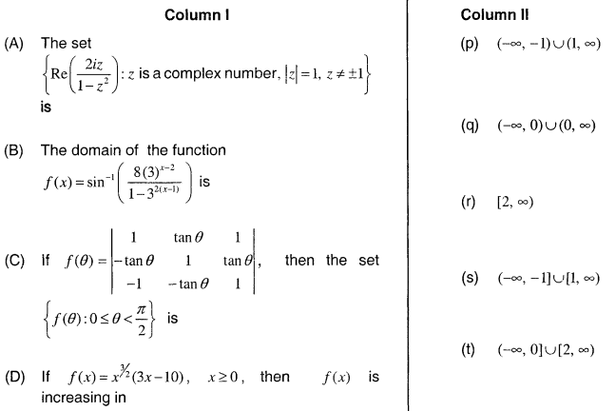

Q1: Let and be real valued functions defined on the interval by
and .
If a, b and c denote, respectively, the absolute maximum of and on , then
- and (b) and
(c) and (d)
Q2: Let The total number of unordered pairs of disjoint subsets of S is equal to :
- 25 (b) 34
(c) 42 (d) 41

Q1: If and and and and given that , then is equal to:
- 5 (b) 10
(c) 0 (d) 15

Q1: Find the range of value of t for which
- (b)
(c) (d)

